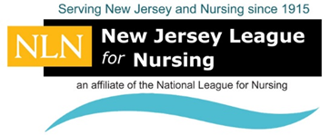
New Jersey League for Nursing (NJLN) 2020 Scholarship Application

Please Type all Information, and Submit Completed Application Package To: info@njln.org

Contact Information
First Name: | M.I. | Last Name:
Address:
City: | State: |  |  |  |  | ZIP Code:
Preferred  Telephone Number: |  | E-Mail Address:
Yes, I am currently a member of the NJLN ☐
Academic and Financial Information

College/School Enrolled:

Current Nursing Program: ☐ LPN ☐ RN ☐ BSN ☐ MSN ☐ Doctoral
Current G.P.A.: | Anticipated Graduation Date:
Current Employer: |  |  |  | Position:
Address: |  |  | City and State:
Status: ☐ Full-time ☐ Part-time |  |  | Years Employed:
State briefly how you are currently financing your education:
How did you learn about the NJLN Scholarship Program?
☐ Colleague ☐ NJLN Website ☐ Financial Aid Office ☐ Dean/Professor ☐ Friend/Family
☐ Other (Indicate Source):

Note: Review the NJLN Scholarship Criteria to ensure you have all required documents before submitting. Completed application and supporting documents must be received no later than Tuesday, September 22, 2020. Submit your entire application package to E-Mail: info@njln.org or mail it to: NJLN P.O. Box 165, Garwood, NJ 07027.
I certify that all information on this application is correct. (check box) ☐
E-Signature of Applicant: |  |  |  |  | Date: Click or tap to enter a date.
For Office Use: App ☐ Transcript ☐
Essay ☐ Reference ☐ Member ☐

