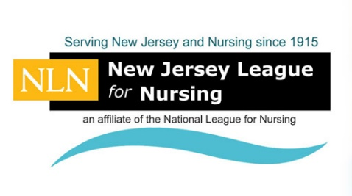
The New Jersey League for Nursing (NJLN) is seeking Exhibitors and Sponsors for our LPN Student Education Day, “Journey Into Practice: Taking The First Steps” to be held Wednesday, April 25, 2018 at the Pines Manor, Rt. 27 (Lincoln Highway), Edison, NJ. Attendees include the Students from the Licensed Practical Nursing Programs throughout New Jersey. The 2017 Event was “Sold-Out” with over 300 attendees. This is an exceptional opportunity for nurse recruitment, educational institutions that offer R.N. degrees, and medical product and service companies. We can only accommodate 10 Exhibitors at this event, so it is important to register early and mail the completed Registration Form with full payment to the NJLN as soon as possible.
NJLN 2018 PRACTICAL NURSE STUDENT
EDUCATION DAY!
Wednesday, April 25, 2018 ~ Pines Manor, Edison, NJ
EXHIBITOR & SPONSORSHIP FORM
Would you like to be an Exhibitor or Sponsor? Please check below:

☐ Nursing Scholarships $1,000 ☐ Morning Breakfast $ 1,000
☐ Luncheon $2,000 ☐ Registration Supplies $ 500
☐ Printing Costs for Event $1,000 ☐ Exhibitor Fee $ 400

☐ Complete Sponsorship ☐ Partial Sponsorship*
*Sponsors have the option of funding an event partially. The minimum donation for a partial sponsorship is $500

Exhibitor Registration includes a six-foot draped table, two chairs, continental breakfast, and lunch for up to two representatives. Sponsors who offer financial support of $1,000 or more will be given a FREE Exhibit table.

EXHIBITORS & SPONSORS - PLEASE COMPLETE THE INFORMATION BELOW

We would like to reserve _____ Exhibit table @ $400 = $_________

We would like to Sponsor the above event at a cost of = $_________

Total Amount Due: $_______________________

Please Complete in Full (Payment Must be Received to Guarantee Exhibitor spot)
Date:
School/Company and Your Title:
First & Last Name:

Street address:
P.O. Box: |  | City: |  |  |  |  |  | State:
Zip Code: |  |  |  | Phone Number: |  |  |  | E-mail Address:
 |  |  |  | ( )
Credit Card that is authorized for use: |  |  | Credit Card # |  |  | Exp. Date: |  |  | Security Code:
☐ Visa or ☐ MasterCard |  |  |  |  | Name on Card:
Payment by Check: ☐ |  |  |  |  | Make Checks payable to the N.J.L.N.

Return Completed Form with Payment by Thursday, March 1, 2018

To: N.J.L.N., 332 North Ave. P.O. Box 165, Garwood, NJ 07027 or

Scan and Email to: info@njln.org
V.01/02/18

