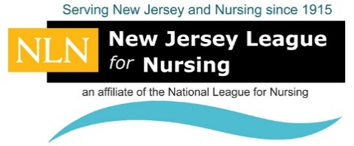
2018 New Jersey League for Nursing (NJLN) Convention Journal Advertisement Contract
Be a part of supporting the NJLN and be seen by reserving your Journal advertising space today! Our annual Convention will be held March 28 & 29, Atlantic City, NJ. Our theme is "Multiple Roles of the New Jersey Nurse: Facing Today’s Challenges Together". Please complete this form and submit your artwork by February 20, and be a part of it! We thank you for your support.
PLEASE RESERVE YOUR ADVERTISING SPACE:
☐ Full Page (7 x 9.5) $325 | ☐ Half Page (7 x 4.5) $250
☐ Quarter Page (3.5 x 4.5) $200 | ☐ Business Card (2.5 x 3.5) $ 50

THE FOLLOWING SPECIAL PAGES ARE AVAILABLE FOR A LIMITED TIME. ALL SIZES ARE 7 X 9.5.
☐ Inside FRONT COVER (ON HOLD) $600 | ☐ Inside LAST PAGE $525
☐ Inside FRONT PAGE ONE $525 | ☐ Outside BACK COVER $600
☐ Inside FRONT PAGE TWO $525 | ☐ Inside BACK COVER (SOLD OUT) $525

SPECIAL INFORMATION FOR YOUR SUBMISSION (please read carefully):
- BLACK AND WHITE CAMERA-READY ARTWORK ONLY. Overall Journal size is 8.5 x 11.
- Camera-ready artwork in .PDF or .DOC file for your Ad, email to info@njln.org
- If camera-ready artwork is unavailable that's no problem, we will develop a text only ad for no additional cost.
- No agency discounts extended. All rates listed are net amount due at the time contract is sent.
- DEADLINE for submitting artwork is to be received no later than FEBRUARY 20, 2018. Complete Form, Scan and E-mail to: info@njln.org, or mail completed form with payment to: NJLN, 332 North Avenue, Garwood, NJ 07027.
Company Name and/or Individual Purchasing Ad:

Address:

City: | State: | Zip Code:
Email: | Telephone: | Fax Number:

Full payment must accompany contract, advance space reservations will be taken, but advertisements will not be printed until full payment is received. (Please check payment method and complete. Note we do not accept American Express). Also, you may use our online process to purchase Advertising: (Click Here)
Please make checks payable to: ☐ New Jersey League for Nursing
(mail check to: NJLN 332 North Ave., P.O. Box 165, Garwood, NJ 07027)
Credit Card: Visa ☐ MasterCard ☐ Credit Card#: Expiration:
Security Code: Name Printed on Card:
Full Billing Address:
For assistance, please contact Susan Chandler, Program Director, at 908-789-3398 or njlnchandler@gmail.com. NJLN, 332 North Avenue, P.O. Box 165, Garwood, NJ 07027. Thank you!
v.1217

