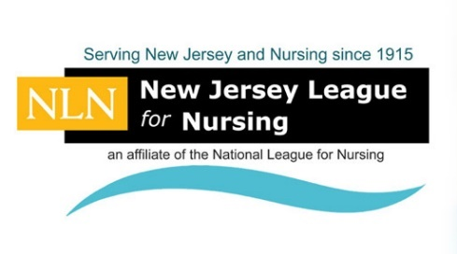
2018 NEW JERSEY LEAGUE FOR NURSING
CONVENTION EVENT SUPPORTER

We are giving Corporations, Healthcare facilities, and Individuals the opportunity to promote your support of Nursing, products and services at the 2018 New Jersey League for Nursing Convention. Event Supporters may select from exclusive or partial funding. Please review the “Supporter Benefits” below for details on the public recognition we offer as our way of saying “thank you”!

OPPORTUNITY PARTIAL EXCLUSIVE
Convention Tote Bags (ON HOLD) - ☐ $5,000
Convention Journal ☐$2,500 ☐$5,000
Premium Co-Branded Badge Holders (SOLD) ☐ $3,500
Branded Mini-Agenda Convention Card (ON HOLD) ☐$2,000
Welcome Reception (Wednesday) ☐$2,000 ☐$5,000
Exhibitors Luncheon ☐$2,000 ☐$4,000
Keynote Speaker ☐$2,000 ☐$4,000
Convention Luncheon Speaker (SOLD) ☐$1,500 ☐$2,500
Healthcare Plenary Speaker ☐$1,000 ☐$2,000
Convention Attendee Pens ☐$1,000 ☐$2,000
Nursing Student Refreshment Break (SOLD) ☐$1,000 ☐$1,500
Morning Refreshments ☐$ 500 -
Attendee Raffle Prizes ☐$ 500 -
NJLN Nursing Scholarship Raffle Prizes ☐$ 300 -
Platinum Luncheon Sponsorship* Ask for details
BENEFITS for SUPPORTERS

- Exclusive Supporters of $3,000 or more include one exhibit booth space FREE of charge,
booth placement in “Supporters Row” prime location; plus other benefits listed below!

- Supporters of $1,000 or more are listed in Convention brochure, if confirmed prior to printing
deadline. (Free booth space is not included in benefits.) This category of Supporter can include one piece of approved company literature in each convention tote bag. Booth placement will be in “Supporters Row” as space allows.

- All supporters are acknowledged in Convention Journal.
- All supporters are publicly thanked at Convention Opening Ceremonies.
- All supporters are prominently displayed on Signage at the Convention.
- All supporters are acknowledged on NJLN web site, post-Convention.
- All supporters receive special ribbons for all attending representatives to wear to acknowledge
special participation and show nurses your support.

2018 NEW JERSEY LEAGUE FOR NURSING
2018 NJLN CONVENTION EVENT SUPPORTER

If the activity you have selected to support is not available, NJLN will transfer your monies to another activity to help defray Convention costs. All transactions are non-refundable.

(PLEASE PRINT)

Company Name:

Address:
Street City State Zip

Contact Person:

Preferred Phone:

E-Mail:

Signature:

Payment is due when Event Supporter form is sent. Amount Enclosed: $

Please charge my credit card for the total shown above: ☐ Visa ☐ MasterCard
(Or contact us directly to process payment, call the NJLN Office 908-789-3398. We do not accept American Express

Credit Card Expiration: Security Code:

Print Name on Card:

Credit Card Billing Address, if different than above:

Please make checks payable to: “NEW JERSEY LEAGUE FOR NURSING”

Please scan and return completed form to E-mail: info@njln.org
Or mail contract and full payment to details to:

NJLN, 332 North Avenue, P.O. Box 165, Garwood, New Jersey 07027

For needed assistance please contact:
Susan Chandler, NJLN, Telephone (908) 789-3398
E-Mail: info@njln.org

THANK YOU FOR YOUR SUPPORT!

